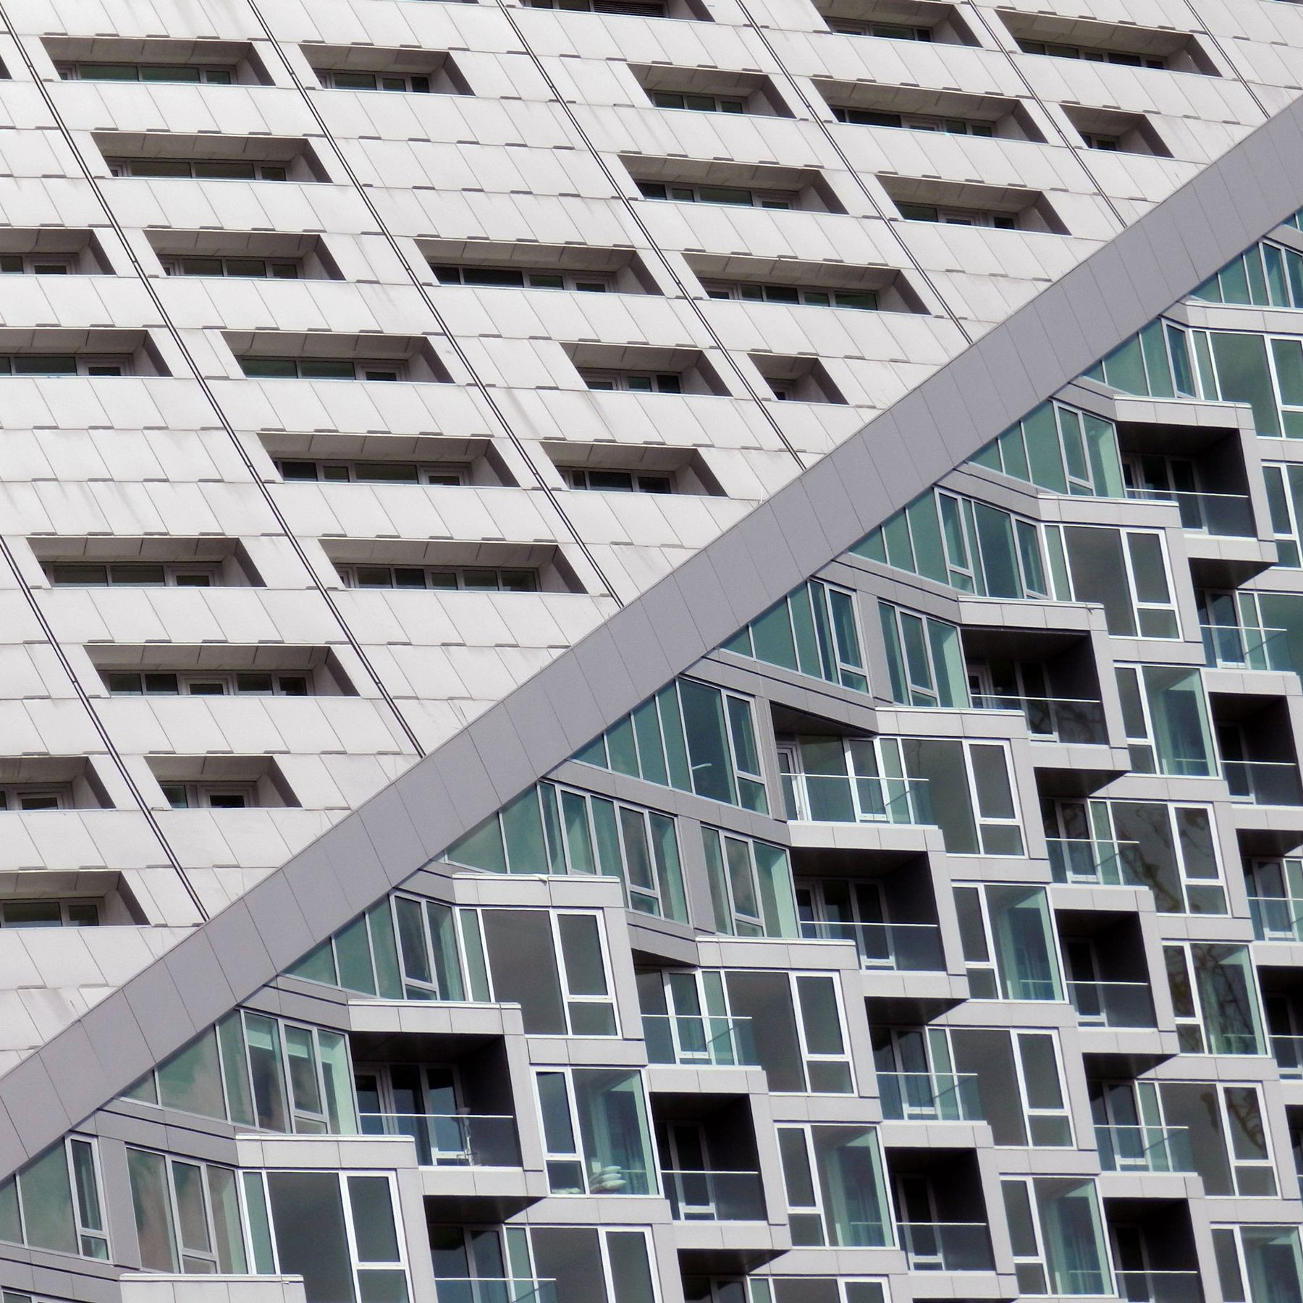
Configuring multi-Area OSPF topology
Evan Gall - CCNP



Evan Gall
Multi-Area OSPF lab
Consists of: Seven Cisco 4321Routers
Network Diagram and IPs
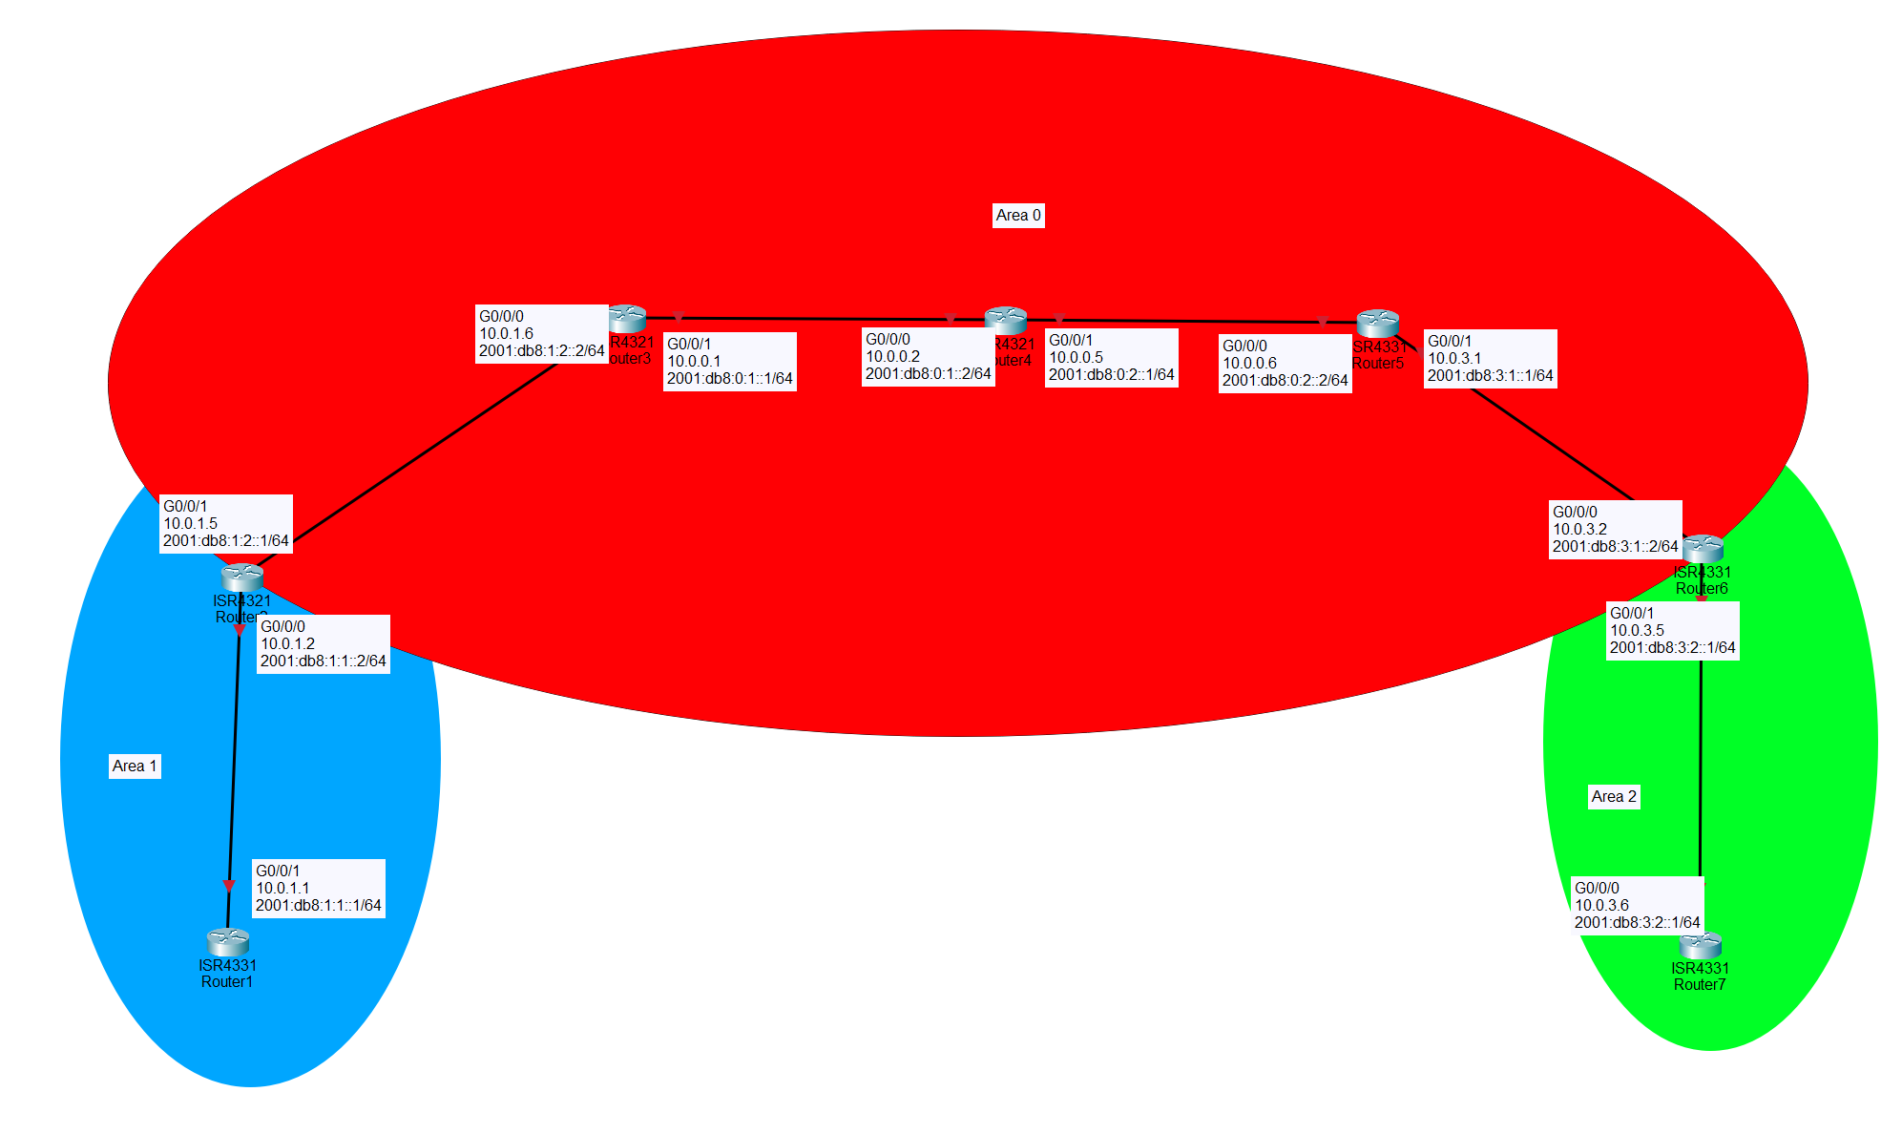
Router # | Interface | Ipv4 Address | Ipv6 Address | OSPF Area #
1 | G0/0/1 | 10.0.1.1 | 2001:db8:1:1::1/64 | 1
2 | G0/0/0 | 10.0.1.2 | 2001:db8:1:1::2/64 | 1
 | G0/0/1 | 10.0.1.5 | 2001:db8:1:2::1/64 | 0
3 | G0/0/0 | 10.0.1.6 | 2001:db8:1:2::2/64 | 0
 | G0/0/1 | 10.0.0.1 | 2001:db8:0:1::1/64 | 0
4 | G0/0/0 | 10.0.0.2 | 2001:db8:0:1::2/64 | 0
 | G0/0/1 | 10.0.0.5 | 2001:db8:0:2::1/64 | 0
5 | G0/0/0 | 10.0.0.6 | 2001:db8:0:2::2/64 | 0
 | G0/0/1 | 10.0.3.1 | 2001:db8:3:1::1/64 | 0
6 | G0/0/0 | 10.0.3.2 | 2001:db8:3:1::2/64 | 0
 | G0/0/1 | 10.0.3.5 | 2001:db8:3:2::1/64 | 2
7 | G0/0/0 | 10.0.3.6 | 2001:db8:3:2::2/64 | 2

Lab Purpose:
Configure and make a Multi Area OSPF Topology. Concepts include IPv4 and IPv6 addressing and Multi-area OSPF. After configuring and connecting the routers, the routers should be all be able to ping each other across the network and be able to see adjacencies through OSPF. Router interfaces should also be in their correct OSPF areas.
Lab Summary:
Make sure all routers can ping each other through IPv4 and IPv6. Routers can see neighbors through OSPF. Did this by applying IPv4 and IPv6 addresses on each router interface with correct subnets, applying OSPF on each interface and using the correct area.
Lab Concepts
OSPF:
Description: Open Shortest Path First (OSPF) is a dynamic routing protocol that allows routers to automatically learn about networks and determine the best paths for sending traffic. Instead of manually entering every route on each router, OSPF allows routers to communicate with one another and exchange information about the their own networks, making routing more efficient and allowing the network to adapt to route and connection changes.
Establishing Neighbor Adjacencies: Routers with OSPF use Hello packets to discover other OSPF routers on directly connected networks. When two routers successfully discover each other with the Hello packets, they form an OSPF neighbor relationship. After becoming neighbors, the routers can exchange information about the networks they know about. This allows each router to build an OSPF database and calculate routes to destinations. In this lab, I used the command: show ip(v6) ospf neigbor, to verify neighbor adjacencies.
Multi-Area OSPF: Multi-area OSPF is the process of breaking down the larger OSPF network into smaller areas (Kind of like subnetting). In doing this, it organizes the network. It also reduces the routing information which the router must process. The backbone area (Area 0) acts as a connecting area for other OSPF areas. For this lab, I configured three areas of OSPF: Area 0, Area 1, and Area 2, where the backbone area of area 0 is in the middle and is used to connect areas 1 and 2. I used the command: ip(v6) ospf 1 area (area #), to establish each interface in their respective areas. The routers in those areas developed a neighbor relationship and shared their routing information with each other among the areas.
Shortest Path First: Another feature of OSPF is the Shortest Path First (SPF) algorithm. The router will consider various aspects like link costs in choosing a particular route. Through SPF, the router will consider aspects like link costs in choosing a route. In the case where there are several possible routes, OSPF will make use of the route that has the lowest cost. In cases where a route is no longer usable, then OSPF will recalculate and choose another available route.

IPv4 and IPv6 Addresses:
Description: IPv4 and IPv6 are two Internet protocols which are used to identify devices and networks using addresses so that they can communicate with one another. I assigned addresses and subnets in this lab to each router, so they can communicate with each other.
IPv4 uses 32-bit addresses and is commonly written in decimal format, such as 192.168.1.1. Because IPv4 has a limited number of available addresses, networks use techniques such as subnetting to divide larger networks into smaller sections. In this lab, IPv4 addresses were assigned to the router interfaces so that each connection belonged to the correct subnet.
IPv6: IPv6 is the newer version of the Internet Protocol and uses 128-bit addresses. IPv6 was adopted as IPv4 had limited addresses. IPv6 provides a much larger address space than IPv4. IPv6 addresses are written using hexadecimal numbers separated by colons, such as 2001:DB8:1::1. IPv6 also includes features designed to improve addressing and routing in modern networks. In order to enable IPv6 pings between routers, use command ipv6 unicast-routing.
Subnetting: Subnetting is the process of dividing up a big IP network into smaller networks known as subnets, which helps organize network devices and manage IP addresses more efficiently. When configuring IPv4 and IPv6, each router interface needs to be assigned an address within the correct subnet or prefix so that devices on the same network can communicate with each other. Proper subnettingDifferent router-to-router connections should generally be used to use different subnets to prevent conflicts and make routing easier to manage. Proper subnetting also ensures that network addresses do not overlap and allows routers to correctly identify which networks are directly connected and which networks must be reached through another router. In this lab, subnetting was used to assign separate IPv4 and IPv6 networks to router connections, allowing the routers to communicate and exchange routing information through OSPF.
Pinging: After assigning the IPv4 and IPv6 addresses, connectivity can be tested using pings. Successful pings between directly connected routers help verify that the interfaces are configured correctly. Pinging addresses across different OSPF areas can also verify that OSPF is successfully learning and advertising routes. In this lab we used commands like pings and trace route to troubleshoot and pinpoint wrong configurationsIn this lab we used commands like pings and trace routes to troubleshoot and pinpoint wrong OSPF and IP configurations
In this lab, both IPv4 and IPv6 routing were configured with OSPF. This allowed the routers to exchange routing information for both types of IP networks and demonstrated how OSPF can be used in a network that supports both IPv4 and IPv6.

Lab Commands
Assigned IPv4 and IPv6 addresses shown in table to each interface + IPv6 unicast routing to allow IPv6 pings
Ex:
Router 1:
>ipv6 unicast-routing
>interface g0/0/1
>ip address 10.0.1.1 255.255.255.252
>ipv6 address 2001:db8:1:1::1/64
OSPF Configuration:
Router 1 example:
>router OSPF 1
>router-id 1.1.1.1
OSPFv2
Router 6 example:
>interface g0/0/0
>ip ospf 1 area 0
>interface g0/0/1
>ip ospf 1 area 2
OSPFv3
Router 2 example:
>interface g0/0/0
>ipv6 ospf 1 area 1
>interface g0/0/1
>ipv6 ospf 1 area 0

-Ipv6 routing enabled with Ipv6 Unicast Routing-
Establishing Neighbor Adjacencies
Verified using:
>show ip ospf neighbor
And for IPv6
>show ipv6 ospf neighbor

Testing Connectivity
IPv4/IPv6 connectivity verified with
>ping (IPv4/IPv6 address)
And
>traceroute (ipv4/ipv6 address)

Problems we encountered:
Mistyped IPV6 address:
I had mistyped the Router 7 G0/0/0 interface’s IPv6 address into the addressing table, and it was the same address as Router 6 G0/0/1.
Troubleshooting it: One problem that occurred as a result was that Router 7 could not ping Router 1 back, however Router 1 was able to ping Router 7’s wrong address. This led us to go into Router 7 and try to figure out why it couldn’t ping across the network. So, we started pinging different routers from Router 7 to see how far the pings will go. Router 7 was able to ping its direct connection, Router 6 G0/0/1, however Router 7 could not ping Router 6 G0/0/0 and past that. So, we figured the problem had to have been between Router 6 and 7 as Router 7 was not able to ping past Router 6. Using show run, I was able to spot the mistyped IPv6 address on Router 7.
Conclusion:
This lab was a good refresher of OSPF and IP addressing I did in CCNA. This lab went smoothly as I was able to troubleshoot the few problems that I had successfully.
Results:
Routers 1 and 7 can ping each other across the network (Meaning other pings between the routers work)
R1 ping R7:
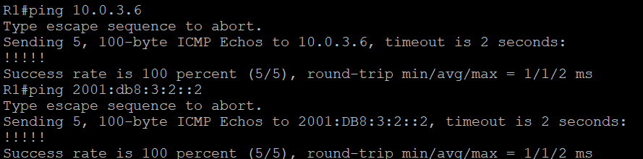
R7 pinging R1
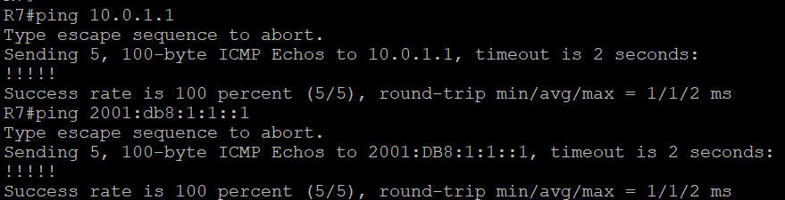
All Routers can see neighbors through OSPF:
Ex: Router 4 being able to see Router 3 and Router 5 (3.3.3.3 is R3 and 5.5.5.5 is R5)
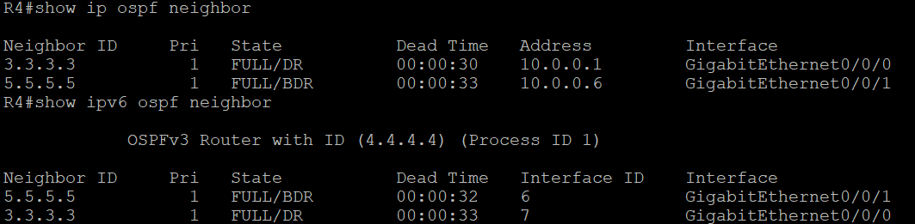
Multi-Area OSPF:
Example: Router 2 G0/0/0 inside area 1, while Router 2 G0/0/1 is in Area 0
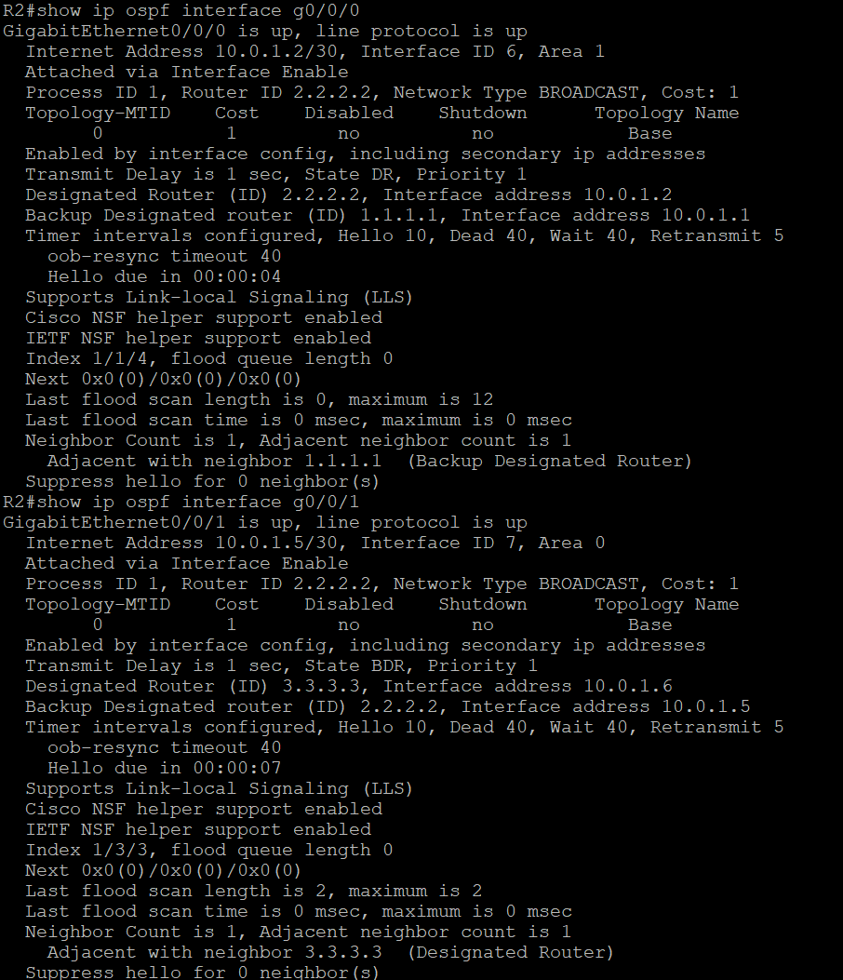

Second example: Router 6 G0/0/0 in Area 0, and G0/0/1 in Area 2
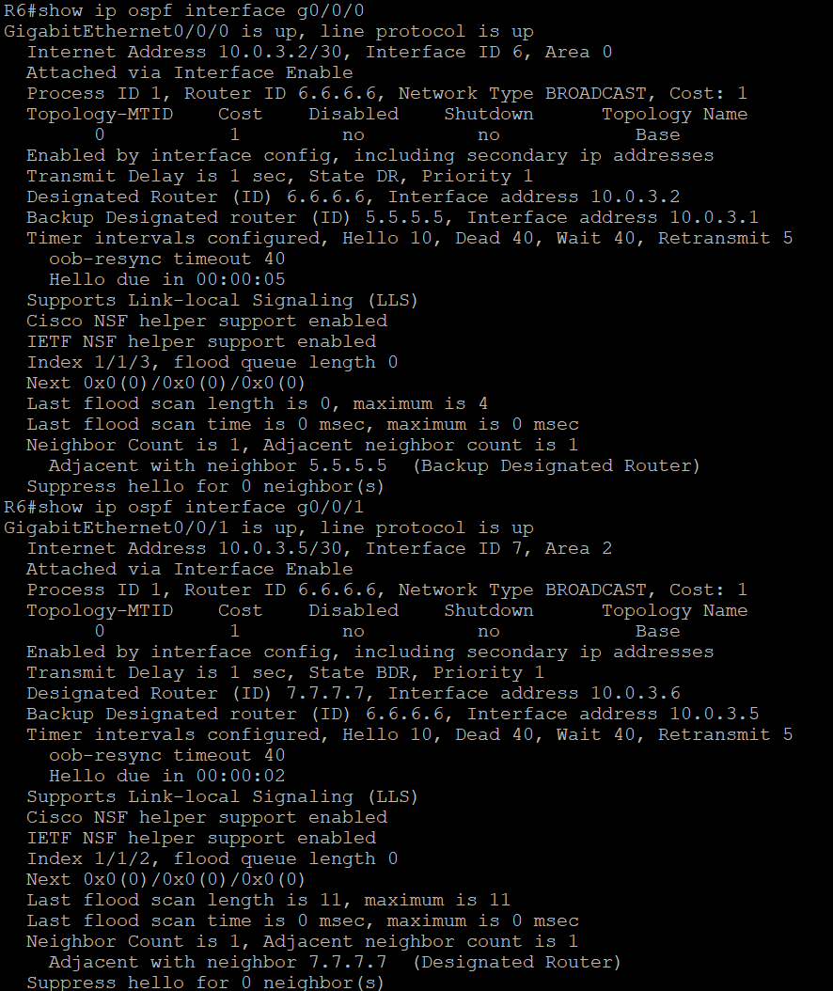

Router Configurations:
-Show ip route, show ospf neighbor, and show run on each router
R1
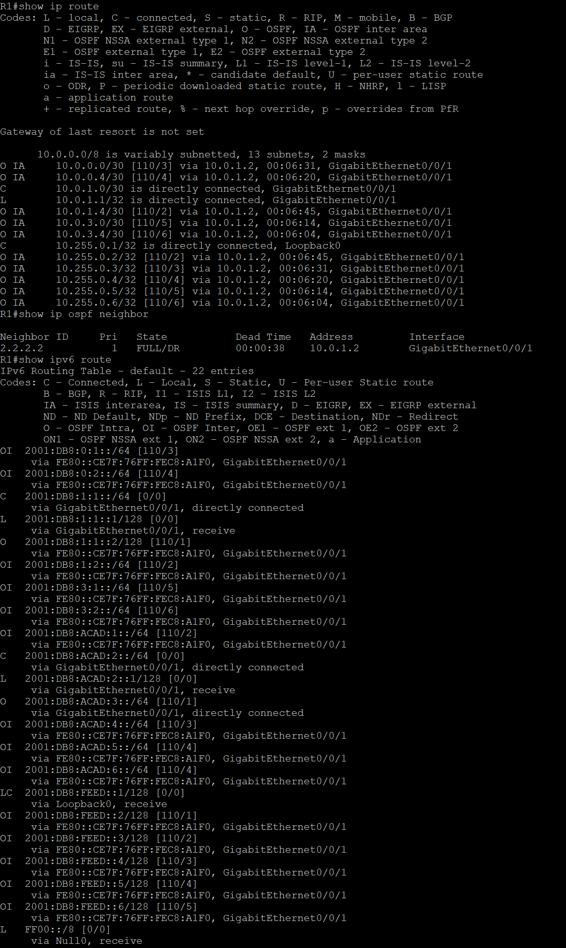

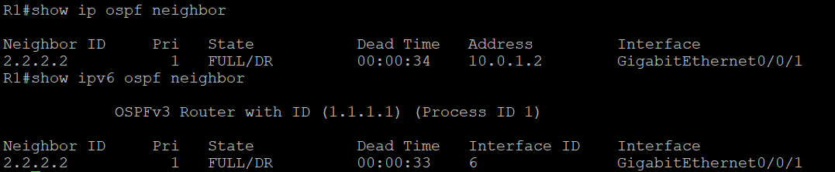

version 16.9
service timestamps debug datetime msec
service timestamps log datetime msec
platform qfp utilization monitor load 80
platform punt-keepalive disable-kernel-core
hostname R1
boot-start-marker
boot-end-marker
vrf definition Mgmt-intf
address-family ipv4
exit-address-family
address-family ipv6
exit-address-family
no aaa new-model
login on-success log
subscriber templating
ipv6 unicast-routing
multilink bundle-name authenticated
crypto pki trustpoint TP-self-signed-859896477
enrollment selfsigned
subject-name cn=IOS-Self-Signed-Certificate-859896477
revocation-check none
rsakeypair TP-self-signed-859896477
crypto pki certificate chain TP-self-signed-859896477
certificate self-signed 01
3082032E 30820216 A0030201 02020101 300D0609 2A864886 F70D0101 05050030
30312E30 2C060355 04031325 494F532D 53656C66 2D536967 6E65642D 43657274
69666963 6174652D 38353938 39363437 37301E17 0D323630 39313431 37353132
355A170D 33303031 30313030 30303030 5A303031 2E302C06 03550403 1325494F
532D5365 6C662D53 69676E65 642D4365 72746966 69636174 652D3835 39383936
34373730 82012230 0D06092A 864886F7 0D010101 05000382 010F0030 82010A02
82010100 C0EB5825 29992AB3 845706F3 C986524B 9DEF8E8E 625F8A9C FD31A5CF
F2DE7340 59298609 AE7589C7 A5250F05 5D285319 C61D0DDB 6F9965D0 67F92027
B44319F3 D6DA9BEB A4102669 9B4FAF18 CD3DE5FF 8B7266A3 8512E1F6 0AA13DF8
C17F09F9 61457046 A57D7456 5F86B649 CBAB3475 A8958B92 1118C94A 2A55AE2B
190DE8F1 C782FB68 9CB04AD9 A14CA3CD 1683D29D 7851C642 BDFA0ECE 3A518CAD
7EE799B0 C4F13975 AC05D95A A031FE6D BDEB14C3 E89A2FF6 2BCC23D0 327054C4
2D9F537C 996A409F 4F37787D F83D6C05 0678B414 A356A5A0 35FAA9FB D1DA7987
0053853A 7823D4DC FA6831A2 020F4A64 03B67183 FDE32EFA FC81473D FD54A545
66007B43 02030100 01A35330 51300F06 03551D13 0101FF04 05300301 01FF301F
0603551D 23041830 168014DF AF73EF44 4B3E1B94 C4D821DF D4CC1F48 01D6EC30
1D060355 1D0E0416 0414DFAF 73EF444B 3E1B94C4 D821DFD4 CC1F4801 D6EC300D
06092A86 4886F70D 01010505 00038201 010058AE 19E7B0E2 2222FCF4 569A038B
C7A97EFF B7E1007A 3A4A8851 42415EEB 5154B9B0 5EF20B46 68F5A24F FC52383D
63EE1F31 AE03804D 7A664588 AEB805FD 07AD46E7 0B5B43F9 F9B043FB A53A8644
B927A924 BE5B9D8B 2736BAAF 54159D0E 580C69D6 48292449 FF80CDF3 0B91BC54
3AAD4406 96443156 6BD771D9 E0665404 E38533EA 5E65F28F 5516D371 57FC4C68
6016E43C D2F9D848 F29258F5 2B92460C 7059B67F EE6EFAEA 0A97396A 29AC5D6C
40B509F8 ABF7E823 9625986B 1D3304EF B18C431C 187DCAC5 68AB1810 5AB268F3
4BC8E657 B8F189C9 F653A2FC 0AC1E787 7E975D79 4A42CC6E 7B4566CE 867F5686
69B00F44 850BCDBD 9B742879 F71A2E9B 4F7A
quit
license udi pid ISR4321/K9 sn FLM240608PJ
no license smart enable
diagnostic bootup level minimal
spanning-tree extend system-id
redundancy
mode none
interface Loopback0
ip address 10.255.0.1 255.255.255.255
ipv6 address 2001:DB8:FEED::1/128
ospfv3 1 ipv6 area 0
interface GigabitEthernet0/0/0
ip address 172.16.1.1 255.255.255.0
ip ospf 1 area 1
negotiation auto
interface GigabitEthernet0/0/1
ip address 10.0.1.1 255.255.255.252
ip ospf 1 area 1
negotiation auto
ipv6 address 2001:DB8:1:1::1/64
ipv6 ospf 1 area 1
interface Serial0/1/0
no ip address
shutdown
interface Serial0/1/1
no ip address
shutdown
interface GigabitEthernet0/2/0
no ip address
shutdown
negotiation auto
interface GigabitEthernet0/2/1
no ip address
shutdown
negotiation auto
interface GigabitEthernet0
vrf forwarding Mgmt-intf
no ip address
shutdown
negotiation auto
router ospfv3 1
router-id 1.1.1.1
address-family ipv6 unicast
area 1 virtual-link 5.5.5.5
exit-address-family
router ospf 1
router-id 1.1.1.1
area 1 virtual-link 5.5.5.5
network 10.255.0.1 0.0.0.0 area 0
network 172.16.1.0 0.0.0.255 area 1
network 172.16.2.0 0.0.0.255 area 0
ip forward-protocol nd
ip http server
ip http authentication local
ip http secure-server
ip tftp source-interface GigabitEthernet0
control-plane
line con 0
transport input none
stopbits 1
line aux 0
stopbits 1
line vty 0 4
login
end

R2
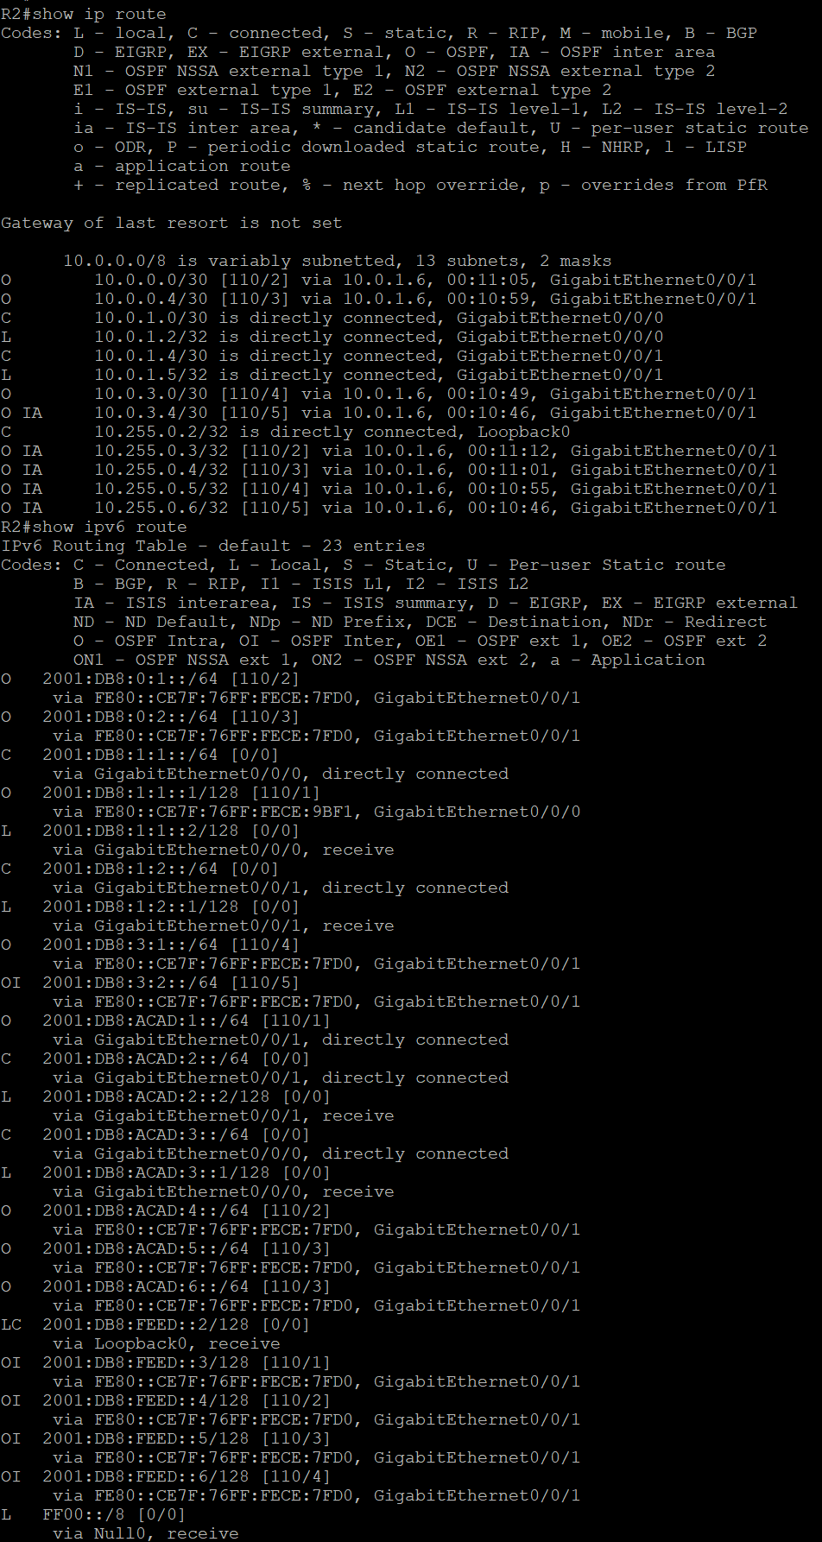
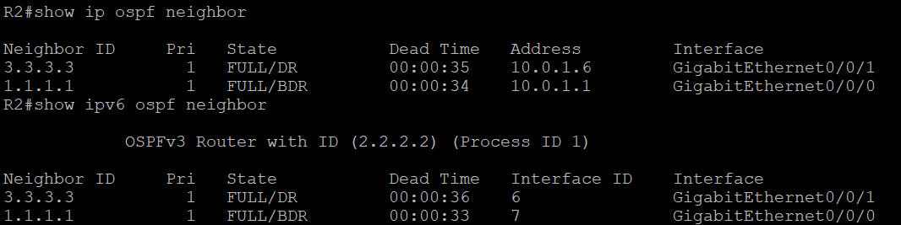
version 16.9
service timestamps debug datetime msec
service timestamps log datetime msec
platform qfp utilization monitor load 80
platform punt-keepalive disable-kernel-core
hostname R2
boot-start-marker
boot-end-marker
vrf definition Mgmt-intf
address-family ipv4
exit-address-family
address-family ipv6
exit-address-family
no aaa new-model
login on-success log
subscriber templating
vtp domain cisco
vtp mode transparent
ipv6 unicast-routing
multilink bundle-name authenticated
crypto pki trustpoint TP-self-signed-4288135047
enrollment selfsigned
subject-name cn=IOS-Self-Signed-Certificate-4288135047
revocation-check none
rsakeypair TP-self-signed-4288135047
crypto pki certificate chain TP-self-signed-4288135047
certificate self-signed 01
30820330 30820218 A0030201 02020101 300D0609 2A864886 F70D0101 05050030
31312F30 2D060355 04031326 494F532D 53656C66 2D536967 6E65642D 43657274
69666963 6174652D 34323838 31333530 3437301E 170D3236 30393134 31373339
34395A17 0D333030 31303130 30303030 305A3031 312F302D 06035504 03132649
4F532D53 656C662D 5369676E 65642D43 65727469 66696361 74652D34 32383831
33353034 37308201 22300D06 092A8648 86F70D01 01010500 0382010F 00308201
0A028201 0100AAE2 03AF5880 8FD4E2FE D25EE8A4 774C6C67 DDA2BE02 4D31D156
5B6DAF42 951594FF 8BBDABDE 0069E4B0 D458553F 8CFE4A78 08849EE8 9BED9FC9
C0506426 776AF982 66746E94 4C67E81B 56E51C64 784A6C59 29E37A84 0539D852
B09C017D 1011B36F 6F91755A AAEBE86B EAE4ECAC 2B1450C8 923BB4BB 572FCADC
5AC8BB7F 424E644C CAD9E091 3D20FB56 0BAAD40B 98A2AD9D 42DF9C39 D0811E05
E89CD1ED 720C1E81 97946E13 2505936F 634DC55A 8F759A0F 09D459B4 13605A5F
FFD13F15 B4519DAB D87DAF43 B4E1414F 1E04642B EFDE0F70 F70D147F 5534954C
0BD13E4F 9A19D902 1997D686 A52D40F7 2822ED9B AECD225B 9399CF08 6D785A3D
0EDDEE16 93AF0203 010001A3 53305130 0F060355 1D130101 FF040530 030101FF
301F0603 551D2304 18301680 144F1C24 21158BDF 13A3DEFE 85D2B54D 7BCD967D
49301D06 03551D0E 04160414 4F1C2421 158BDF13 A3DEFE85 D2B54D7B CD967D49
300D0609 2A864886 F70D0101 05050003 82010100 8CA4C3E4 9A464D89 260E6E99
B8E427B3 6450E1E0 DA2E3983 961E33F2 C158D7AC E7168DA2 C158DDCE B1CCF6AC
FB9B725C 1A30D5E5 6BE64A61 3E1C884D 070F7F99 34DEBA5F 88CCA035 617EF401
38231161 817E3186 B1711537 A9FCA13B D6FF4F7D 9A030388 826D421E DE80194E
723BC6F9 DC28ED90 70D76306 0D4BA71A 52B6D2E3 ECC14ED6 9A8D82DF 5686AD60
A62019AA 6C932292 248630A3 2A0C48A5 2EC17A3B 63FE3522 C4609395 4DDA7A99
3A7B7FE6 16729705 10F447F8 E47765F9 1A174E7E F1843D9E 24F6190A 83C43706
1CECE820 ECCE57C5 A3565DB1 3ECC10B2 A1773A25 FEED9F12 477892FC E4A6E849
56A4A697 6C8ABB1A D9C8E332 C377B50D D96E381D
quit
license udi pid ISR4321/K9 sn FLM2406090M
no license smart enable
diagnostic bootup level minimal
spanning-tree extend system-id
redundancy
mode none
interface Loopback0
ip address 10.255.0.2 255.255.255.255
ipv6 address 2001:DB8:FEED::2/128
ospfv3 1 ipv6 area 0
interface GigabitEthernet0/0/0
ip address 10.0.1.2 255.255.255.252
ip ospf 1 area 1
negotiation auto
ipv6 address 2001:DB8:1:1::2/64
ipv6 ospf 1 area 1
interface GigabitEthernet0/0/1
ip address 10.0.1.5 255.255.255.252
ip ospf 1 area 0
negotiation auto
ipv6 address 2001:DB8:1:2::1/64
ipv6 ospf 1 area 0
interface Serial0/1/0
no ip address
shutdown
interface Serial0/1/1
no ip address
shutdown
interface GigabitEthernet0
vrf forwarding Mgmt-intf
no ip address
shutdown
negotiation auto
router ospfv3 1
router-id 2.2.2.2
address-family ipv6 unicast
area 1 virtual-link 4.4.4.4
exit-address-family
router ospf 1
router-id 2.2.2.2
area 1 virtual-link 4.4.4.4
network 10.255.0.2 0.0.0.0 area 0
network 172.16.2.0 0.0.0.255 area 0
network 172.16.3.0 0.0.0.255 area 1
ip forward-protocol nd
ip http server
ip http authentication local
ip http secure-server
ip tftp source-interface GigabitEthernet0
control-plane
line con 0
transport input none
stopbits 1
line aux 0
stopbits 1
line vty 0 4
login
end

R3
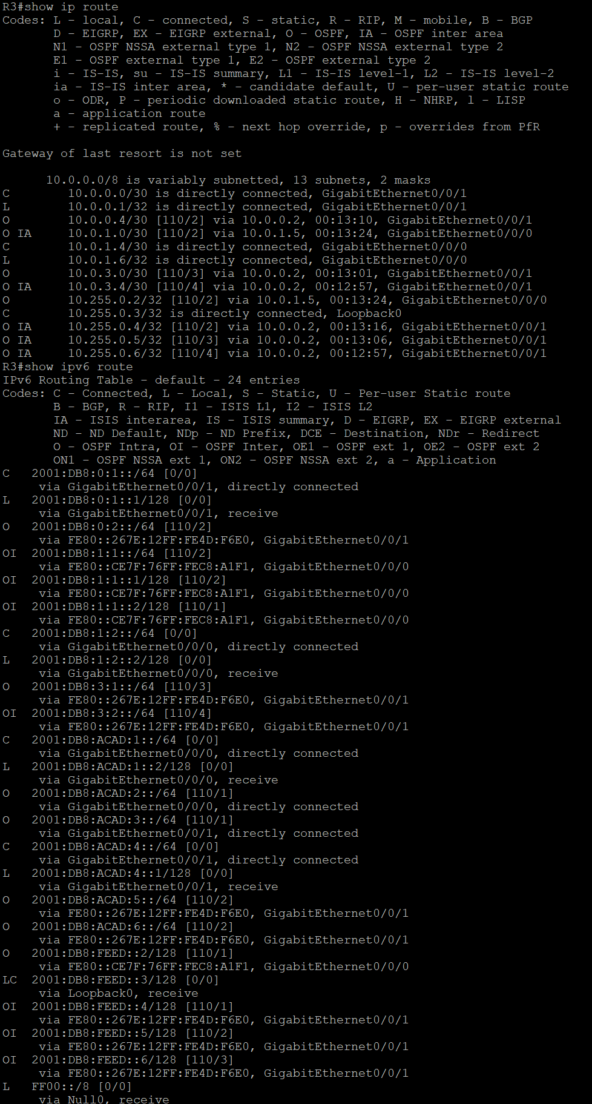
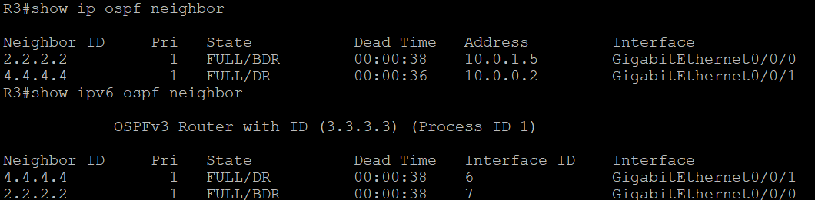
version 16.9
service timestamps debug datetime msec
service timestamps log datetime msec
platform qfp utilization monitor load 80
platform punt-keepalive disable-kernel-core
hostname R3
boot-start-marker
boot-end-marker
vrf definition Mgmt-intf
address-family ipv4
exit-address-family
address-family ipv6
exit-address-family
no aaa new-model
login on-success log
subscriber templating
vtp domain cisco
vtp mode transparent
ipv6 unicast-routing
multilink bundle-name authenticated
crypto pki trustpoint TP-self-signed-2951285168
enrollment selfsigned
subject-name cn=IOS-Self-Signed-Certificate-2951285168
revocation-check none
rsakeypair TP-self-signed-2951285168
crypto pki certificate chain TP-self-signed-2951285168
certificate self-signed 01
30820330 30820218 A0030201 02020101 300D0609 2A864886 F70D0101 05050030
31312F30 2D060355 04031326 494F532D 53656C66 2D536967 6E65642D 43657274
69666963 6174652D 32393531 32383531 3638301E 170D3236 30393134 31383039
35395A17 0D333030 31303130 30303030 305A3031 312F302D 06035504 03132649
4F532D53 656C662D 5369676E 65642D43 65727469 66696361 74652D32 39353132
38353136 38308201 22300D06 092A8648 86F70D01 01010500 0382010F 00308201
0A028201 0100D0F4 1ED61E6C 96123455 652236BC D78B034E 90D31E21 62BDECCA
70F3F2A3 C9818F77 EB5726E8 1B535859 AA255971 1B59AA2D 04EE95F4 4D5FCCE4
0A084860 28EE3EFE EBEE6118 01A4D9A2 71B6431E 51B9A791 5B02D333 67D26BD9
464DDA11 A84F1A76 B12439CE 0A3B3208 4D8D534F A0BD9BAB 4DED70E6 26C0A4FF
E567A7E1 03A8455E B06D5C89 0F19F4AF 623DE69A 3F4E2D12 F99AE6D4 9A102084
97BDF7FE B1EC143C 85657E17 768F3552 B77FDEBD 2DB53D48 2BCB9B79 06FCE11E
1EAA16E1 533AE851 FDFA5C76 78173DCA 01E7A68E A5B2BECF A1691669 A51188BF
F771D3FC 9D3A069E 57F2233B 0D1B75F3 03FF2F38 A8D4DC57 0B14AEA6 32223300
47A1FFA5 266F0203 010001A3 53305130 0F060355 1D130101 FF040530 030101FF
301F0603 551D2304 18301680 1499AA82 7EBDB420 F4CF21E4 E443FEB7 497C6F7F
55301D06 03551D0E 04160414 99AA827E BDB420F4 CF21E4E4 43FEB749 7C6F7F55
300D0609 2A864886 F70D0101 05050003 82010100 63E38458 8123F1B6 489B338F
10EB7A54 E3B5E406 274DF241 11BF5BF2 91F6FEC2 1843F86A 4BCABEB7 5CBF66A0
EF532E9E 1A4AC585 79A41B7D 96723F7E 652E2F22 D8AD816F 8E3241CA D3B3E665
DD528279 C956D43B 828C9BD1 2FCD3566 99B52D1B 3BCEF11B 77D4224D 71658E78
40BF7581 CB19D374 F304B6AE 568CF07A F74E0947 49FE08B3 67069B73 9ACBFDD6
75AC3B78 14947DCD 3FC7699A 9CDE111B 6029AC4D ACC7B6CC 14E02A05 30947808
F0516D8B 9E15ACE6 64B51EC8 F2AEFBCC 15F2F78D FA21776C 9ED52D79 8F2E429E
F2A21DF7 7F646301 140C8E6E DCDFA239 EF8A5BA7 E9F8AB85 1DAC5E4A 37990C26
B6A752C4 E6E54AD8 ADA20ADC D64E3115 C2A019FF
quit
license udi pid ISR4321/K9 sn FLM240608H7
no license smart enable
diagnostic bootup level minimal
spanning-tree extend system-id
redundancy
mode none

interface Loopback0
ip address 10.255.0.3 255.255.255.255
ipv6 address 2001:DB8:FEED::3/128
ospfv3 1 ipv6 area 1
interface GigabitEthernet0/0/0
ip address 10.0.1.6 255.255.255.252
ip ospf 1 area 0
negotiation auto
ipv6 address 2001:DB8:1:2::2/64
ipv6 ospf 1 area 0
interface GigabitEthernet0/0/1
ip address 10.0.0.1 255.255.255.252
ip ospf 1 area 0
negotiation auto
ipv6 address 2001:DB8:0:1::1/64
ipv6 ospf 1 area 0
interface Serial0/1/0
no ip address
shutdown
interface Serial0/1/1
no ip address
shutdown
interface GigabitEthernet0
vrf forwarding Mgmt-intf
no ip address
shutdown
negotiation auto
router ospfv3 1
router-id 3.3.3.3
address-family ipv6 unicast
exit-address-family
router ospf 1
router-id 3.3.3.3
network 10.255.0.3 0.0.0.0 area 1
network 172.16.1.0 0.0.0.255 area 1
network 172.16.4.0 0.0.0.255 area 1
ip forward-protocol nd
ip http server
ip http authentication local
ip http secure-server
ip tftp source-interface GigabitEthernet0
control-plane
line con 0
transport input none
stopbits 1
line aux 0
stopbits 1
line vty 0 4
login
end

R4
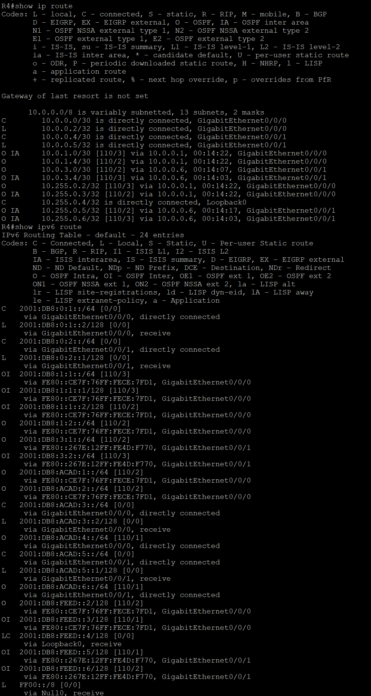
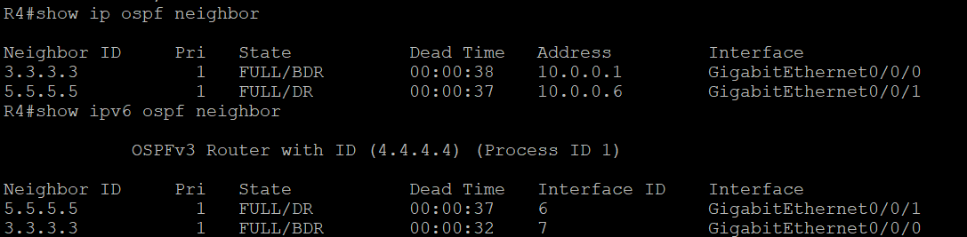

version 16.9
service timestamps debug datetime msec
service timestamps log datetime msec
platform qfp utilization monitor load 80
platform punt-keepalive disable-kernel-core
hostname R4
boot-start-marker
boot-end-marker
vrf definition Mgmt-intf
address-family ipv4
exit-address-family
address-family ipv6
exit-address-family
no aaa new-model
login on-success log
subscriber templating
vtp domain cisco
vtp mode transparent
ipv6 unicast-routing
multilink bundle-name authenticated
crypto pki trustpoint TP-self-signed-4013003437
enrollment selfsigned
subject-name cn=IOS-Self-Signed-Certificate-4013003437
revocation-check none
rsakeypair TP-self-signed-4013003437
crypto pki certificate chain TP-self-signed-4013003437
certificate self-signed 01
30820330 30820218 A0030201 02020101 300D0609 2A864886 F70D0101 05050030
31312F30 2D060355 04031326 494F532D 53656C66 2D536967 6E65642D 43657274
69666963 6174652D 34303133 30303334 3337301E 170D3236 30393134 31373438
35315A17 0D333030 31303130 30303030 305A3031 312F302D 06035504 03132649
4F532D53 656C662D 5369676E 65642D43 65727469 66696361 74652D34 30313330
30333433 37308201 22300D06 092A8648 86F70D01 01010500 0382010F 00308201
0A028201 0100CD0F 7D66D873 3DA2BC5C 4DD7DA3B 71329979 EA38DD8C 2CB8F4F2
0ED9F608 E9653D04 548409FC 5AFE754C C7B6FACF C72B13D5 D658109F F8A3BED4
68EFCE87 8FBDDC77 9323FFDA EAF919B9 D02633F2 2A6E4BCF EE370244 591D4954
25B25732 39BAEE59 B8D9C7A0 E5D3C22D 7765641E 7EA1AC33 62342A7E 052E9A59
75853C62 3C4C1A53 81D0EE04 8CC955C2 7FA45B40 C49F54D9 06746120 E7D007CE
CB5CEF38 C82C54AA 2F431137 F5B7BF94 0A8CCB2A 6038F8F7 E979F055 44DE2751
A22806E4 94BD5825 A9A8FE6F 7F15CC17 1FB1F850 672E2166 20D3F2CC 785D2942
722DA203 6ECECB37 AD586B0A 408FB27C 9EB89220 3380335D 2C370FB1 4F847B72
B30F07F9 D0130203 010001A3 53305130 0F060355 1D130101 FF040530 030101FF
301F0603 551D2304 18301680 14FEFCBE 4E2F5F71 3B70B4F8 382B71B8 9AAA03BD
B2301D06 03551D0E 04160414 FEFCBE4E 2F5F713B 70B4F838 2B71B89A AA03BDB2
300D0609 2A864886 F70D0101 05050003 82010100 04F365E0 621A8BF5 136CD839
B8BEDD93 E7A9EA81 D9FB200E EA99ADAB 60F17378 C6525358 B1EE3B92 3E21A0D7
6600486F D2FADF0D 9BA2E361 EADE6CC1 746C4297 4AB5BB9E 4F164C6D 2B451502
1912D062 69E84E29 0E106C78 5F0BCC2E 56C66FCB D5C6C6F7 34679321 9D9411A7
D1335D13 20FBE470 6D8B819A 58D10F13 98DF69AC 1C99AADE 0BB811D4 99BFA2FD
C86448C8 928F015A 1A1297AC 261C919C 20CFB82E 6FC90390 EC075027 7498314E
21E4B331 08E2352C 3BD158D4 11D028DA DFC1793D B80E3760 B1D3BED2 3E215056
EEE9504A 867D4EFA E18C5EC1 E84F35A0 3FA1C6AE ECC9EC6F 2472B487 DA0DC8E6
E0507428 7D67CDC5 A32CA70F 584A2DA2 A51D93E7
quit
license udi pid ISR4321/K9 sn FDO21482HZX
license boot level appxk9
no license smart enable
diagnostic bootup level minimal
spanning-tree extend system-id
redundancy
mode none
interface Loopback0
ip address 10.255.0.4 255.255.255.255
ipv6 address 2001:DB8:FEED::4/128
ospfv3 1 ipv6 area 1
interface GigabitEthernet0/0/0
ip address 10.0.0.2 255.255.255.252
ip ospf 1 area 0
negotiation auto
ipv6 address 2001:DB8:0:1::2/64
ipv6 ospf 1 area 0
interface GigabitEthernet0/0/1
ip address 10.0.0.5 255.255.255.252
ip ospf 1 area 0
negotiation auto
ipv6 address 2001:DB8:0:2::1/64
ipv6 ospf 1 area 0
interface Serial0/1/0
no ip address
shutdown
interface Serial0/1/1
no ip address
shutdown
interface GigabitEthernet0
vrf forwarding Mgmt-intf
no ip address
shutdown
negotiation auto
router ospfv3 1
router-id 4.4.4.4
address-family ipv6 unicast
area 1 virtual-link 2.2.2.2
exit-address-family
router ospf 1
router-id 4.4.4.4
area 1 virtual-link 2.2.2.2
network 10.255.0.4 0.0.0.0 area 1
network 172.16.3.0 0.0.0.255 area 1
network 172.16.5.0 0.0.0.255 area 3
ip forward-protocol nd
ip http server
ip http authentication local
ip http secure-server
ip tftp source-interface GigabitEthernet0
control-plane
line con 0
transport input none
stopbits 1
line aux 0
stopbits 1
line vty 0 4
login
end

R5
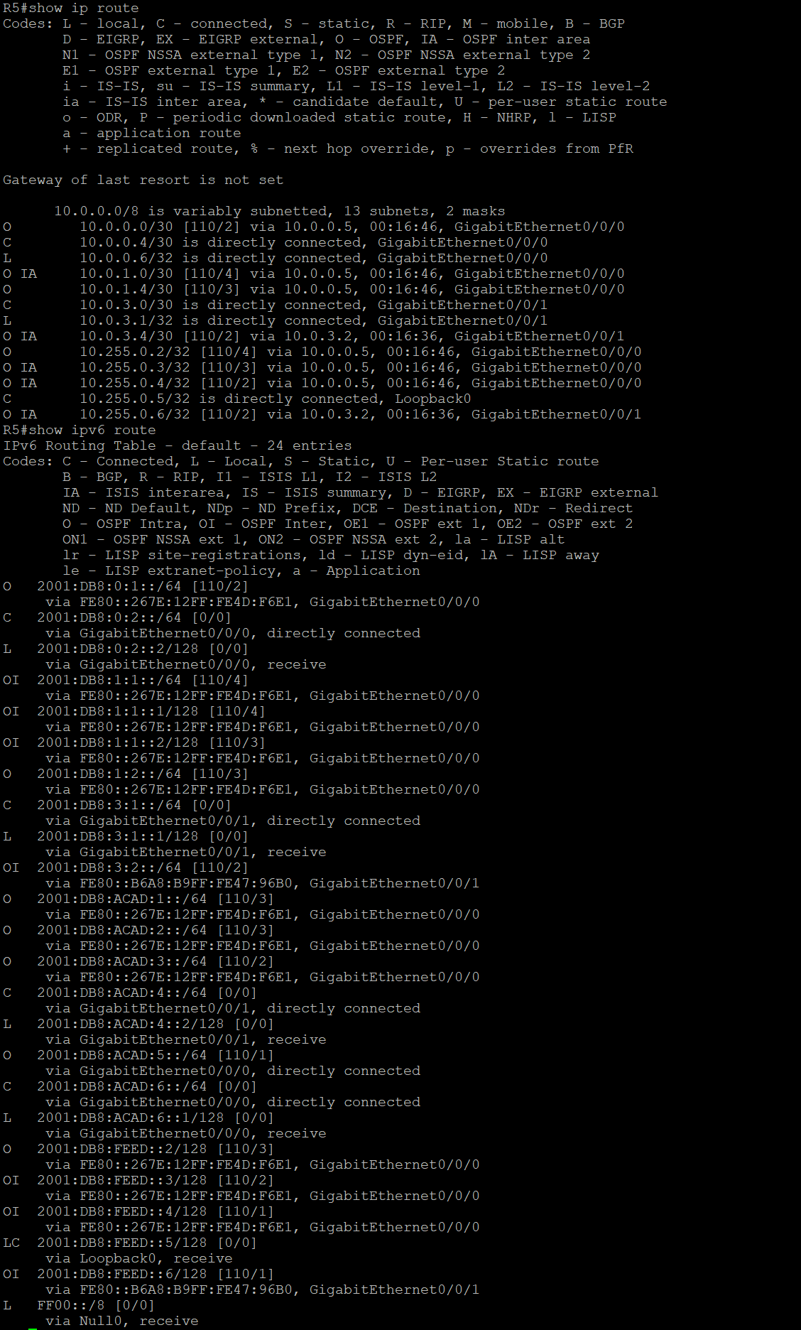
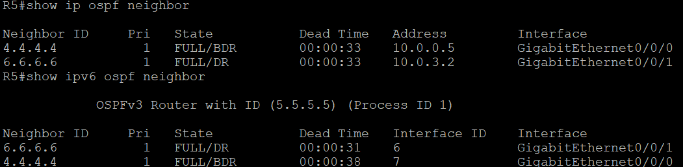
version 16.9
service timestamps debug datetime msec
service timestamps log datetime msec
platform qfp utilization monitor load 80
platform punt-keepalive disable-kernel-core
hostname R5
boot-start-marker
boot-end-marke
vrf definition Mgmt-intf
address-family ipv4
exit-address-family
address-family ipv6
exit-address-family
no aaa new-model
login on-success log
subscriber templating
vtp domain cisco
vtp mode transparent
ipv6 unicast-routing
multilink bundle-name authenticated
crypto pki trustpoint TP-self-signed-2105456491
enrollment selfsigned
subject-name cn=IOS-Self-Signed-Certificate-2105456491
revocation-check none
rsakeypair TP-self-signed-2105456491
crypto pki certificate chain TP-self-signed-2105456491
certificate self-signed 01
30820330 30820218 A0030201 02020101 300D0609 2A864886 F70D0101 05050030
31312F30 2D060355 04031326 494F532D 53656C66 2D536967 6E65642D 43657274
69666963 6174652D 32313035 34353634 3931301E 170D3236 30393134 31373531
32365A17 0D333030 31303130 30303030 305A3031 312F302D 06035504 03132649
4F532D53 656C662D 5369676E 65642D43 65727469 66696361 74652D32 31303534
35363439 31308201 22300D06 092A8648 86F70D01 01010500 0382010F 00308201
0A028201 0100D42F C98751EC 7ACE15DD 29C451E2 664E78E7 1A1F0FF4 C26718DC
C918618A C7427B98 128962C6 69C32467 78566F42 657DF0F9 FF09EE47 692AF294
89AA5402 D7430B8B B2E5B665 ABB3BEEC 0FE0D1A9 57C2736E F0750F91 DC81C783
48572F54 21E2577B 4B511ED7 85FC1C07 FCD05CAF 03C9A2F6 0E76AB83 E72AD750
96764CE5 B947D862 BD1CA18C 71A207ED C33F7FF4 74FF8E40 9A1E0A4F B0E6CFE4
D5B6AE6A 3D2F9811 E69EBA80 0BBB7EF4 115A4F8E F69615F2 7C16C03D 016A3D32
8FABE02D 09870A6D 1146AF9F 7A1595E7 CD129293 1A95399B C154CE73 0643C8CF
0BDBBDCE 730171BB E3F3B5EC 1AB78A1A 8C7B650B B536E21D F9B19A3A 7954644C
52492876 910B0203 010001A3 53305130 0F060355 1D130101 FF040530 030101FF
301F0603 551D2304 18301680 149AD520 A13BA6EB DF3F794E A6DCC043 AC6F50AB
D5301D06 03551D0E 04160414 9AD520A1 3BA6EBDF 3F794EA6 DCC043AC 6F50ABD5
300D0609 2A864886 F70D0101 05050003 82010100 598B2B95 6D33E4BF E26493E7
9CBE9D30 5F6B3CA7 2E765BC0 AEC3A154 2533138F 3A048CD4 757C6E8C 03A436C0
8F7CD4C5 8CC9858F 933692D1 2BD807AD BD9AB554 17C1D293 8790387A E1D27E01
1B5DAC53 91FFE4ED 13DF6B88 44D02657 C4BCFE41 22E9AF67 BED33C49 FDC77671
E063A02A 49FD3681 7D03A03B 1D0C9103 A812A75C 08D2E874 DFEFEB74 83E7D803
235EA1F8 4A2015F8 DE91212C 47F3F05C 72FFAFB0 87EBC45F B2F08B39 3F7B5237
20316A8C 27BEF1E7 DE3F6450 2A83F875 BA58740A EBC50990 679A5D15 E6015740
42EC07F3 B2F9DFDC FD8444AA AE747698 D8A1DFE5 8CD6F197 B8D78239 A08938F4
A62AAB1E FF4D19BB 69F5B9F2 7819AD94 952C8C18
quit
license udi pid ISR4321/K9 sn FDO21482DWJ
license boot level appxk9
no license smart enable
diagnostic bootup level minimal
spanning-tree extend system-id
redundancy
mode none
interface Loopback0
ip address 10.255.0.5 255.255.255.255
ipv6 address 2001:DB8:FEED::5/128
ospfv3 1 ipv6 area 1

interface GigabitEthernet0/0/0
ip address 10.0.0.6 255.255.255.252
ip ospf 1 area 0
negotiation auto
ipv6 address 2001:DB8:0:2::2/64
ipv6 ospf 1 area 0
interface GigabitEthernet0/0/1
ip address 10.0.3.1 255.255.255.252
ip ospf 1 area 0
negotiation auto
ipv6 address 2001:DB8:3:1::1/64
ipv6 ospf 1 area 0
interface Serial0/1/0
no ip address
shutdown
interface Serial0/1/1
no ip address
shutdown
interface GigabitEthernet0
vrf forwarding Mgmt-intf
no ip address
shutdown
negotiation auto
router ospfv3 1
router-id 5.5.5.5
address-family ipv6 unicast
area 1 virtual-link 1.1.1.1
exit-address-family
router ospf 1
router-id 5.5.5.5
area 1 virtual-link 1.1.1.1
network 10.255.0.5 0.0.0.0 area 1
network 172.16.4.0 0.0.0.255 area 1
network 172.16.6.0 0.0.0.255 area 3
ip forward-protocol nd
ip http server
ip http authentication local
ip http secure-server
ip tftp source-interface GigabitEthernet0
control-plane
line con 0
transport input none
stopbits 1
line aux 0
stopbits 1
line vty 0 4
login
end

R6
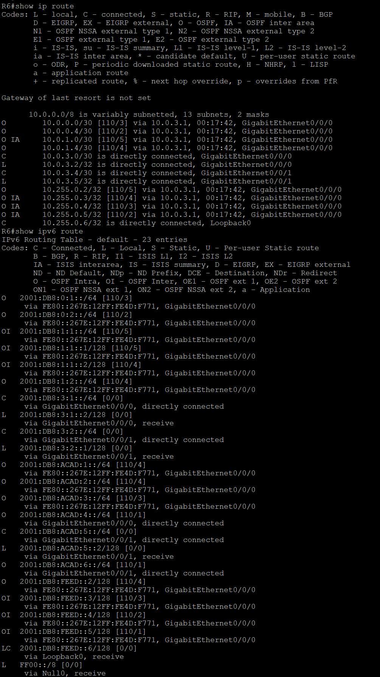
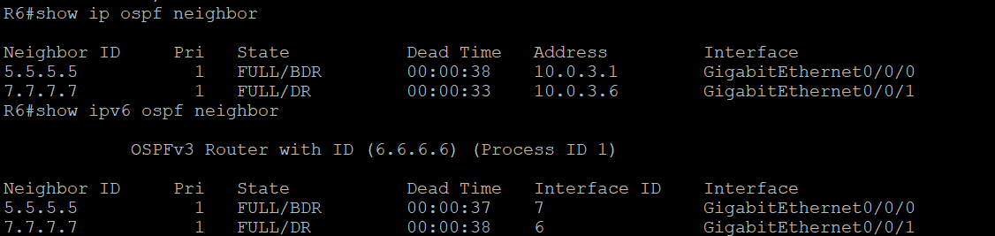
version 16.9
service timestamps debug datetime msec
service timestamps log datetime msec
platform qfp utilization monitor load 80
platform punt-keepalive disable-kernel-core
hostname R6
boot-start-marker
boot-end-marker
vrf definition Mgmt-intf
address-family ipv4
exit-address-family
address-family ipv6
exit-address-family
no aaa new-model
login on-success log
subscriber templating
vtp domain cisco
vtp mode transparent
ipv6 unicast-routing
multilink bundle-name authenticated
crypto pki trustpoint TP-self-signed-2517694527
enrollment selfsigned
subject-name cn=IOS-Self-Signed-Certificate-2517694527
revocation-check none
rsakeypair TP-self-signed-2517694527
crypto pki certificate chain TP-self-signed-2517694527
certificate self-signed 01
30820330 30820218 A0030201 02020101 300D0609 2A864886 F70D0101 05050030
31312F30 2D060355 04031326 494F532D 53656C66 2D536967 6E65642D 43657274
69666963 6174652D 32353137 36393435 3237301E 170D3236 30393134 31373439
33325A17 0D333030 31303130 30303030 305A3031 312F302D 06035504 03132649
4F532D53 656C662D 5369676E 65642D43 65727469 66696361 74652D32 35313736
39343532 37308201 22300D06 092A8648 86F70D01 01010500 0382010F 00308201
0A028201 0100B961 64779F6C 1306E73A 9C083DE3 27FFC2CB 3F50F727 1E52067E
2BEC96AC FB0FF525 32CC4C65 9E9E342D 01B8130C E20E5F1D 2FA67E03 27CF6E17
A65C9161 73D24D28 3D800F47 BE6E9FB1 39340E28 83882492 4648E69E 0A473DCA
74EB4A7B FA50717B DD4DC8FC 63FAFB70 8E046B94 BE2DDCFF C651469F 9981BC28
7801DDC8 7E0E92C4 E017E285 5E718A66 3E3CF115 04F78013 C825C124 09C34B8A
8846D2A2 D537741A C4AC8FE3 6BB3D49F 5DAD28CF EB0111A8 C0E92A8D 6676E281
72577F5E A739132B 11865BC7 A81145AE 246C689E 56400938 882573E4 CF585864
E0AE0808 3CA2FE84 D21F15CF 0F3735D6 3E6C437E 91F74BE0 9B58A060 7BB376EF
E956E836 A4250203 010001A3 53305130 0F060355 1D130101 FF040530 030101FF
301F0603 551D2304 18301680 140CD832 AF18E0CD 18E0874A 1F912C71 D6F771CF
69301D06 03551D0E 04160414 0CD832AF 18E0CD18 E0874A1F 912C71D6 F771CF69
300D0609 2A864886 F70D0101 05050003 82010100 496E6D38 AD2AAC03 1C5FE749
C29F36C4 AA7FAF35 B0E464B1 8FFA99B6 F99C80A5 72F10C6B A11B0615 EE8D192A
63C62049 05531E25 0EF51F03 01F79B9D A61BE68A B037A9B0 D3DDBF3B E891FF91
804C5D12 DCF7725B A386C39C 335063C4 75F1DB25 8D0ABCC8 B76FCC41 50DAA805
C48E57F9 32F53037 C9CA46B1 79A14F0F C6BBA68D ACAC0E64 218CB6FD 3B83068A
5EDDFA65 93DC9565 29B72BCA EB52C872 7741F2DA C233207A 2646E70C BD8FE844
9C4903F3 6F2A3E2D 9591A030 784F172C B163B7AA 6B08BD18 A3BB6983 1CF1C451
3D6B5DBA F637BF5A F1507972 E9A348A1 F3BA92B6 A0CCFC86 D536EF6B D7AC9F9E
858C34F0 46C9499B 54BA21AC 5FF8DCA8 896B1515
quit
license udi pid ISR4321/K9 sn FDO214414VU
no license smart enable
diagnostic bootup level minimal
spanning-tree extend system-id
redundancy
mode none
interface Loopback0
ip address 10.255.0.6 255.255.255.255
ipv6 address 2001:DB8:FEED::6/128
ospfv3 1 ipv6 area 3
interface GigabitEthernet0/0/0
ip address 10.0.3.2 255.255.255.252
ip ospf 1 area 0
negotiation auto
ipv6 address 2001:DB8:3:1::2/64
ipv6 ospf 1 area 0

interface GigabitEthernet0/0/1
ip address 10.0.3.5 255.255.255.252
ip ospf 1 area 2
negotiation auto
ipv6 address 2001:DB8:3:2::1/64
ipv6 ospf 1 area 2
interface Serial0/1/0
no ip address
shutdown
interface Serial0/1/1
no ip address
shutdown
interface GigabitEthernet0/2/0
no ip address
shutdown
negotiation auto
interface GigabitEthernet0/2/1
no ip address
shutdown
negotiation auto
interface GigabitEthernet0
vrf forwarding Mgmt-intf
no ip address
shutdown
negotiation auto
router ospfv3 1
router-id 6.6.6.6
address-family ipv6 unicast
exit-address-family
router ospf 1
router-id 6.6.6.6
network 10.255.0.6 0.0.0.0 area 3
network 172.16.5.0 0.0.0.255 area 3
ip forward-protocol nd
ip http server
ip http authentication local
ip http secure-server
ip tftp source-interface GigabitEthernet0
control-plane
line con 0
transport input none
stopbits 1
line aux 0
stopbits 1
line vty 0 4
login
end

R7
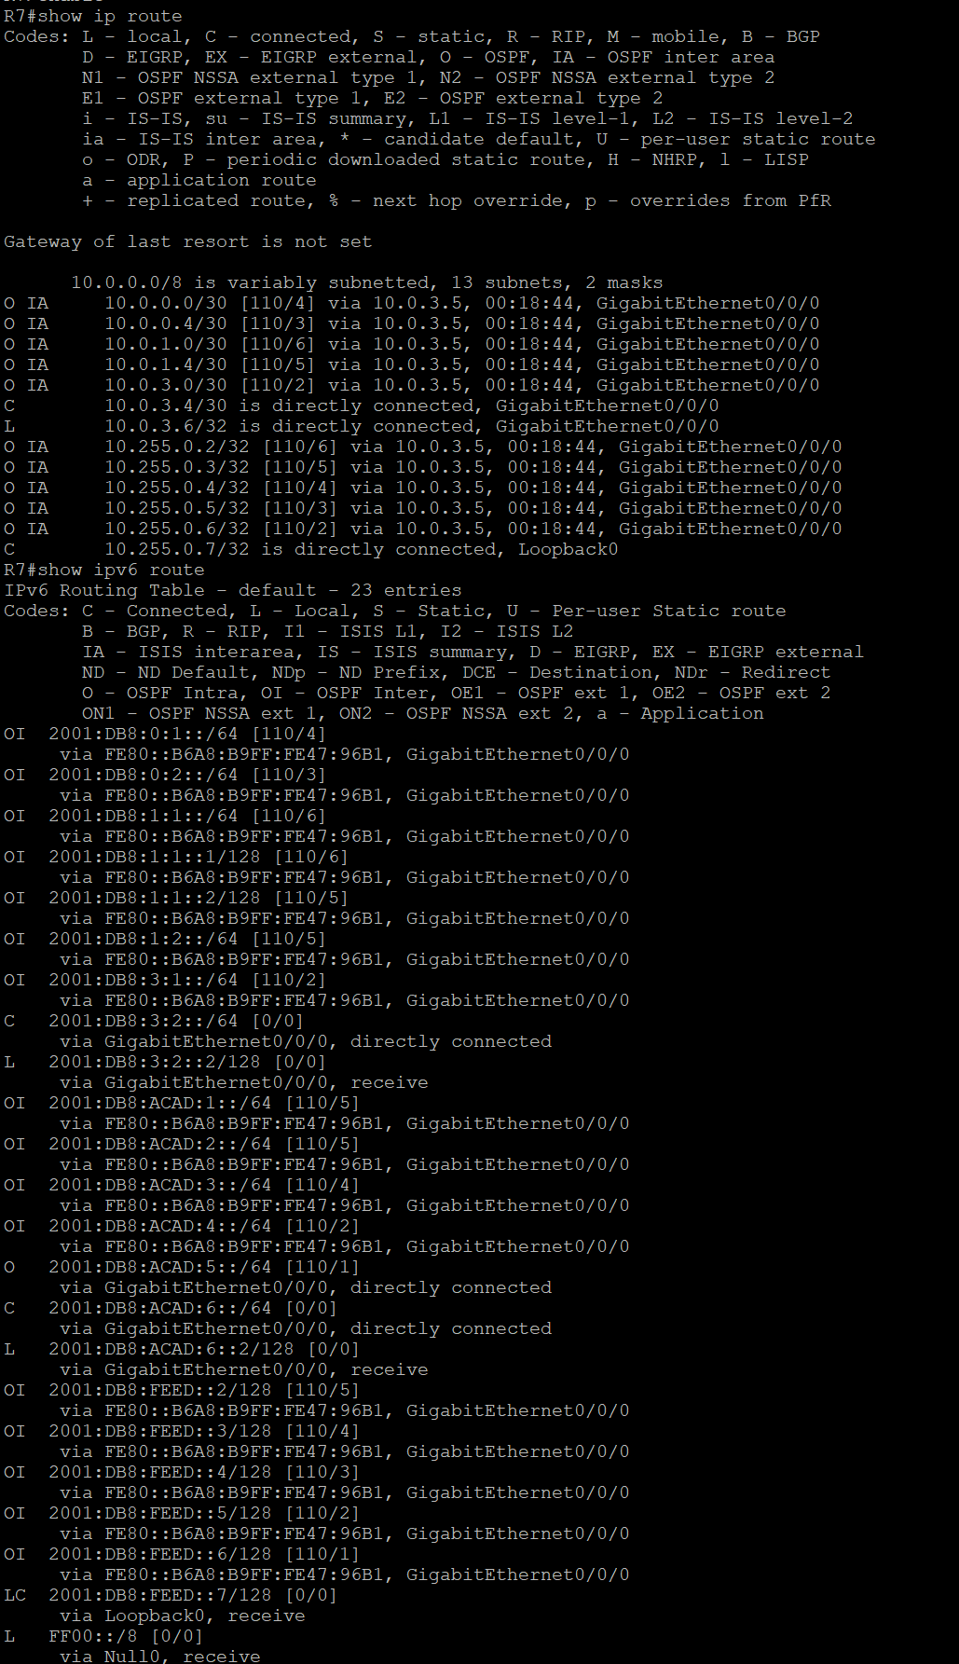
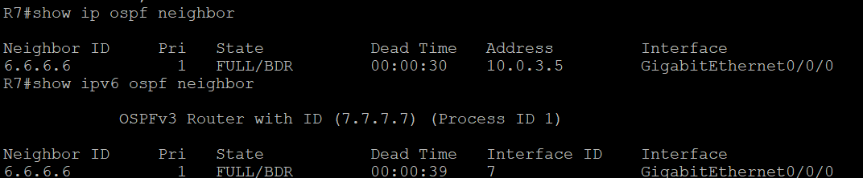
version 16.9
no service timestamps debug uptime
no service timestamps log uptime
platform qfp utilization monitor load 80
platform punt-keepalive disable-kernel-core
hostname R7
boot-start-marker
boot-end-marker
vrf definition Mgmt-intf
address-family ipv4
exit-address-family
address-family ipv6
exit-address-family
no aaa new-model
login on-success log
subscriber templating
vtp domain cisco
vtp mode transparent
ipv6 unicast-routing
multilink bundle-name authenticated
crypto pki trustpoint TP-self-signed-1049204796
enrollment selfsigned
subject-name cn=IOS-Self-Signed-Certificate-1049204796
revocation-check none
rsakeypair TP-self-signed-1049204796
crypto pki certificate chain TP-self-signed-1049204796
certificate self-signed 01
30820330 30820218 A0030201 02020101 300D0609 2A864886 F70D0101 05050030
31312F30 2D060355 04031326 494F532D 53656C66 2D536967 6E65642D 43657274
69666963 6174652D 31303439 32303437 3936301E 170D3236 30393134 31373438
30335A17 0D333030 31303130 30303030 305A3031 312F302D 06035504 03132649
4F532D53 656C662D 5369676E 65642D43 65727469 66696361 74652D31 30343932
30343739 36308201 22300D06 092A8648 86F70D01 01010500 0382010F 00308201
0A028201 0100E7C6 0208FD86 D40D1410 CC15461E 4A5AABA8 C2D58F27 FA5A6E4E
D0FAB967 EBDFA8AB A194D2C8 CC3B913D 20E74663 56DD4350 9332DD18 97E53EBA
325306D6 9516BEC4 EDFDE1D0 2F25DF71 91C8679C B674CA96 01654E15 8DC30576
D1BF1D15 E6AD253D D044C2A5 E680A924 8F8536F6 50351E7D F2EC4667 EECCCA4F
474270AE 58D109E3 C2A51527 1880C96E 1F5AA61C 71113CBD 1F7BBDEE 5B162DA7
A9FB4B46 212839A1 A910020C C95EF5F3 646A55BB B51839FE 8AEB7881 B467E248
38D3754B 66945932 3D0961DC 1B75BB59 BC3A778C 587EEA54 47397019 175DA272
B6B00DBB C78FD62E 5A671FCE E4D7121D A3A65AF6 779E2773 523A3627 E3938527
0EECE59B 855F0203 010001A3 53305130 0F060355 1D130101 FF040530 030101FF
301F0603 551D2304 18301680 14AEC1D6 0A70C004 1330C60E CC9A715C 9F51D35B
63301D06 03551D0E 04160414 AEC1D60A 70C00413 30C60ECC 9A715C9F 51D35B63
300D0609 2A864886 F70D0101 05050003 82010100 E2A8D3F0 B566F68F B93953D8
0E49A1BA 17C6B09D 6389E952 79145D64 1E82679D 1FF2E5BF 327E130E CDF1661D
862EFB46 FAD8267A 404DB8EA 01690A6E 084B55F0 0728DC80 8FA46F26 76CC4921
8823F6D5 43630444 AE4F089F 4A5155CB 2BC34EEF 8F7D7F91 0508EB31 3EC38080
9BADC0BE 838B3F88 AE486F68 D12B0176 467CB1F3 C54D0739 7BFE28AD 79177457
A832C279 2E2FEBF8 8C48C609 DC40E926 FC8A2D10 00F8623E 21BEB16C 28DDE887
B33C044D 02481CE7 3FEEC684 FD82DCB5 AA06FB32 417D56EA 1328C5EF 194DD732
C1EB9D7B BA27AC88 D6FB8718 35FF8165 70324924 7E609BAE 497439D6 53835165
FFEE5D85 F1B2CEAD 2E6C4793 66112BC9 C1628ACA
quit
license udi pid ISR4321/K9 sn FDO214421CH
no license smart enable
diagnostic bootup level minimal
spanning-tree mode pvst
spanning-tree extend system-id
redundancy
mode none
interface Loopback0
ip address 10.255.0.7 255.255.255.255
ipv6 address 2001:DB8:FEED::7/128
ospfv3 1 ipv6 area 3
interface GigabitEthernet0/0/0
ip address 10.0.3.6 255.255.255.252
ip ospf 1 area 2
negotiation auto
ipv6 address 2001:DB8:3:2::2/64
ipv6 ospf 1 area 2
interface GigabitEthernet0/0/1
no ip address
negotiation auto
interface Serial0/1/0
no ip address
shutdown
interface Serial0/1/1
no ip address
shutdown
interface Service-Engine0/2/0
no ip address
interface GigabitEthernet0
vrf forwarding Mgmt-intf
no ip address
shutdown
negotiation auto
router ospfv3 1
router-id 7.7.7.7
address-family ipv6 unicast
exit-address-family
router ospf 1
router-id 7.7.7.7
network 10.255.0.7 0.0.0.0 area 3
network 172.16.6.0 0.0.0.255 area 3
ip forward-protocol nd
ip http server
ip http authentication local
ip http secure-server
ip tftp source-interface GigabitEthernet0
control-plane
line con 0
transport input none
stopbits 1
line aux 0
stopbits 1
line vty 0 4
login
end

